EXPERIMENT 24
Create a CI/CD Pipeline Using GitHub Actions
AIM
To create a CI/CD pipeline using GitHub Actions to automate the building, testing, Docker image publishing, and deployment of a containerized Flask application to a cloud platform.

THEORY
GitHub Actions is a CI/CD automation platform integrated with GitHub repositories. Workflow files written in YAML define events, jobs and steps that run automatically. In this experiment, a Flask application is containerized using Docker. GitHub Actions checks out the source code, installs dependencies, runs tests, builds the Docker image, logs in to Docker Hub, pushes the image, and deploys the application to a cloud platform such as Heroku. Repository secrets are used to protect credentials and deployment tokens.

PROCEDURE
- Create a GitHub repository for the containerized Flask application.
- Create the Flask application and Dockerfile.
- Create the GitHub Actions workflow file under .github/workflows/deploy.yml.
- Configure the workflow to run automatically when code is pushed to the main branch.
- Add steps to check out the repository, set up Python, install dependencies and run tests.
- Add Docker build and Docker Hub login steps.
- Build and push the Docker image to Docker Hub.
- Configure cloud deployment credentials using GitHub repository secrets.
- Add the deployment step for the selected cloud platform.
- Push the workflow and source files to GitHub.
- Open the Actions tab and verify that the workflow completes successfully.
- Open the deployment URL and verify the running Flask application.

IMPLEMENTATION
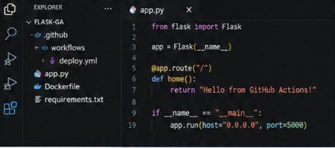
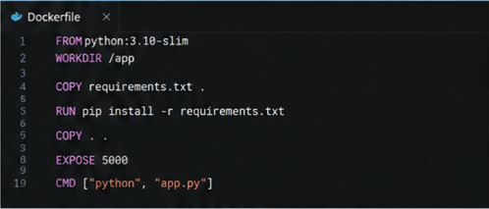
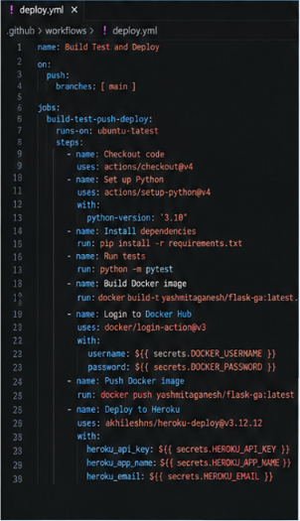
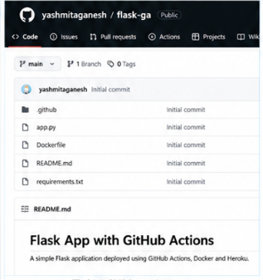
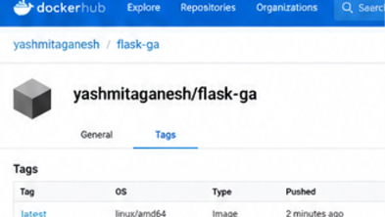
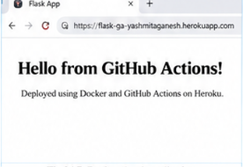

IMPLEMENTATION DETAILS
Parameter | Value
CI/CD Platform | GitHub Actions
Source Repository | GitHub
Application | Python Flask
Containerization | Docker
Image Registry | Docker Hub
Docker Image | yashmitaganesh/flask-ga:latest
Workflow File | .github/workflows/deploy.yml
Trigger | Push to main
Pipeline Stages | Checkout → Test → Build → Push → Deploy
Deployment Platform | Heroku
Deployment URL | https://flask-ga-yashmitaganesh.herokuapp.com

GITHUB ACTIONS WORKFLOW
name: Build Test and Deploy
on:
push:
branches: [ main ]
jobs:
build-test-push-deploy:
runs-on: ubuntu-latest
steps:
- name: Checkout code
uses: actions/checkout@v4
- name: Set up Python
uses: actions/setup-python@v4
with:
python-version: '3.10'
- name: Install dependencies
run: pip install -r requirements.txt
- name: Run tests
run: python -m pytest
- name: Build Docker image
run: docker build -t yashmitaganesh/flask-ga:latest .
- name: Login to Docker Hub
uses: docker/login-action@v3
with:
username: ${{ secrets.DOCKER_USERNAME }}
password: ${{ secrets.DOCKER_PASSWORD }}
- name: Push Docker image
run: docker push yashmitaganesh/flask-ga:latest
- name: Deploy to cloud
run: echo "Deploy application to configured cloud platform"

OUTPUT
The GitHub Actions workflow successfully checked out the Flask project, installed its dependencies, executed the tests, built the Docker image, authenticated with Docker Hub, pushed the image, and completed the configured cloud deployment. The deployed Flask application was accessible through the deployment link.

RESULT
Thus, a CI/CD pipeline was successfully created using GitHub Actions for a containerized Flask application. The complete workflow automated testing, Docker image creation, Docker Hub publishing, and cloud deployment.

CONCLUSION
This experiment demonstrates how GitHub Actions can integrate source control, automated testing, Docker image management and cloud deployment into a repeatable CI/CD workflow.

